- Prepare the javascript file (here .mjs) for the monitoring:

------------------------------runLighthouse.mjs-----------------------------
import { launch } from 'chrome-launcher';
import { writeFileSync, mkdirSync, existsSync } from 'fs';
import { join, dirname } from 'path';
import { fileURLToPath } from 'url';
import lighthouse from 'lighthouse';

const __dirname = dirname(fileURLToPath(import.meta.url));

async function runLighthouse(url, reportDir) {
const chrome = await launch({ chromeFlags: ['--headless'] });
const options = { logLevel: 'info', output: 'html', onlyCategories: ['performance'], port: chrome.port };
const runnerResult = await lighthouse(url, options);

// Create directory if it doesn't exist
if (!existsSync(reportDir)) {
mkdirSync(reportDir, { recursive: true });
}

// Save the HTML report to a file
const reportHtml = runnerResult.report;
const reportPath = join(reportDir, 'lighthouse-report.html');
writeFileSync(reportPath, reportHtml);

console.log(`Report is done for ${runnerResult.lhr.finalUrl}`);
console.log(`Performance score was ${runnerResult.lhr.categories.performance.score * 100}`);

await chrome.kill();
}

async function runLighthouseForMultipleSites(urls) {
for (const url of urls) {
const domain = new URL(url).hostname.replace(/\./g, '_');
const reportDir = join(__dirname, 'lighthouse-reports', domain);
await runLighthouse(url, reportDir);
}
}

const urls = [
'https://wrkny.com/',
'https://fe-apparel.com/',
'https://www.awchang.com/'
];

runLighthouseForMultipleSites(urls);

- Now prepare the windows batch file to programmatically publish all the reports for the websites:

---------------------publish_reports.bat------------------------------

@echo off
setlocal enabledelayedexpansion

set "report_base=%WORKSPACE%\lighthouse-reports"
set "target_base=%WORKSPACE%\htmlreports"

if not exist "%target_base%" (
mkdir "%target_base%"
)

for /D %%d in ("%report_base%\*") do (
set "report_dir=%%d"
set "report_name=%%~nxd"
if exist "!report_dir!\lighthouse-report.html" (
echo Publishing report for !report_name!
if not exist "%target_base%\!report_name!" (
mkdir "%target_base%\!report_name!"
)
copy "!report_dir!\lighthouse-report.html" "%target_base%\!report_name!\"
)
)

- Login to Jenkins and make sure these are configured:

- Plugins should be enabled:
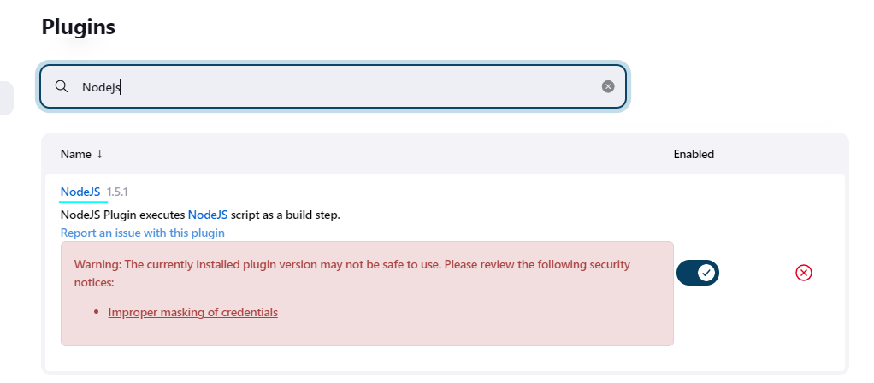

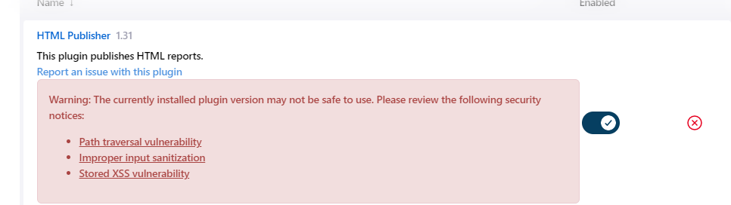

- Global Tools Configuration:
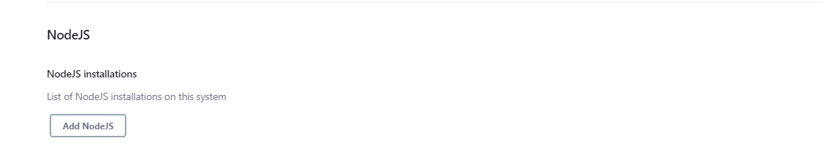

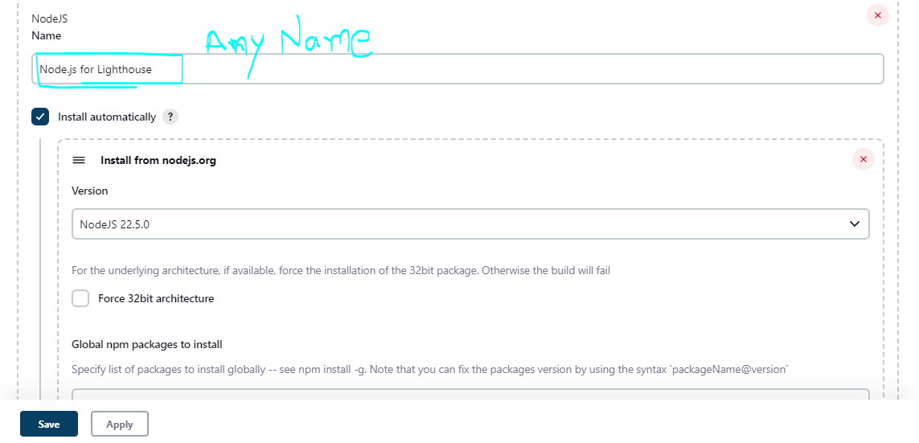

Save and Apply

- Create a New Item (Freestyle Project):
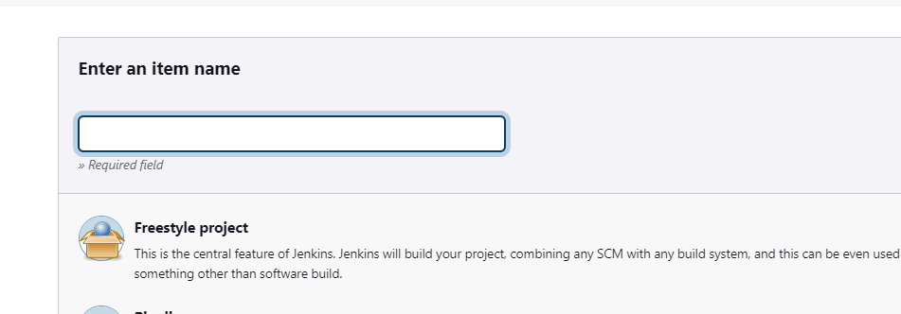

Give it a name (In our case Lighthouse-Monitor).
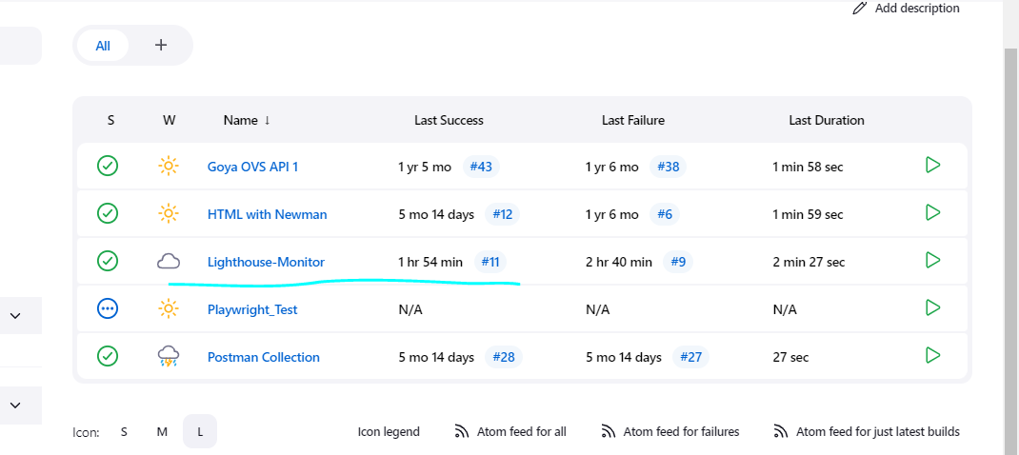------------------------------------------------------------------------------------

- Configure the Project:
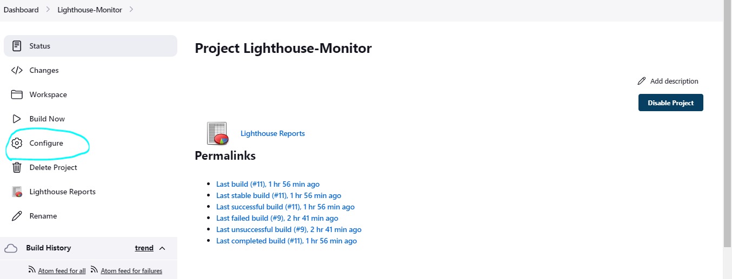

- Add the Build Environment:
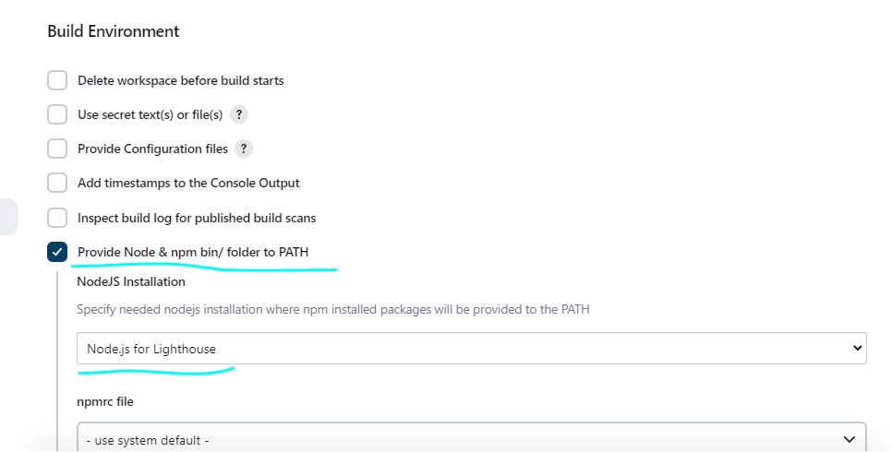

(select the node.js installation that we configured above in Global Configuration)

- Add this Build Step for Windows Batch Command:

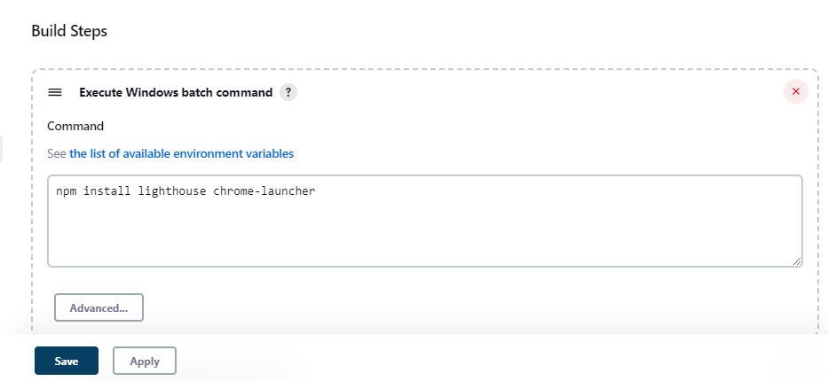

Save and Apply.
Then do a Build Now:
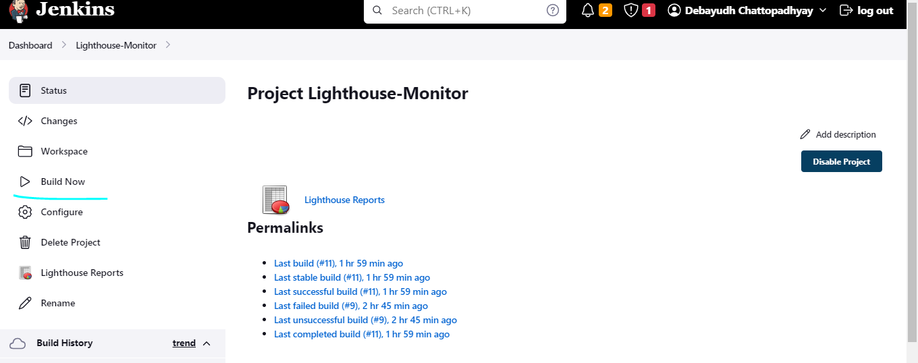

Wait for the Build to be successful.
Once this build is done, a workspace will be created under Jenkins with the given Project Name:

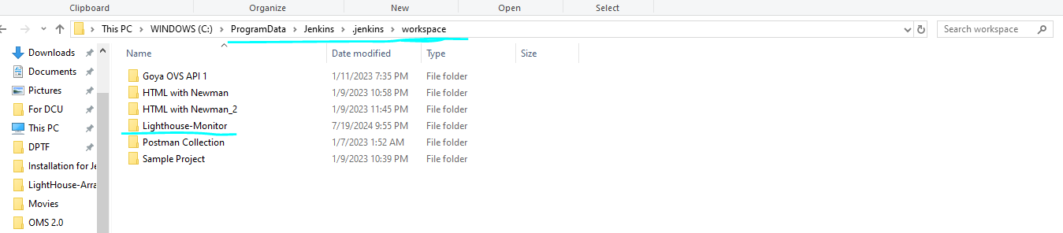

Copy the .mjs file and the bat file that we have prepared in this location:
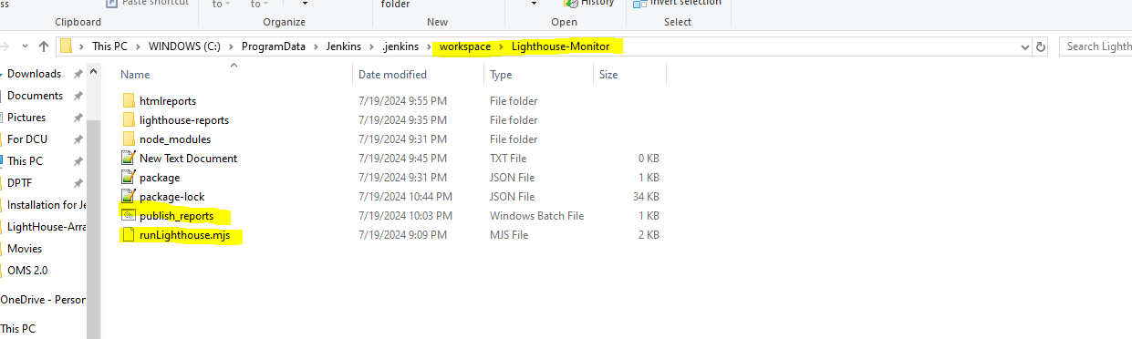

- Add more batch commands to run the .mjs file
Get back to the Jenkins project – Configure and add another Build Step:
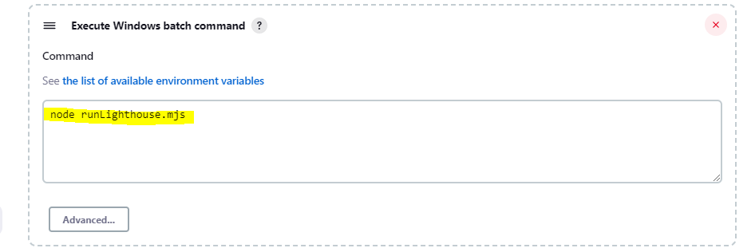

- Add Build Step to run the publish_reports.bat script after the Lighthouse script:
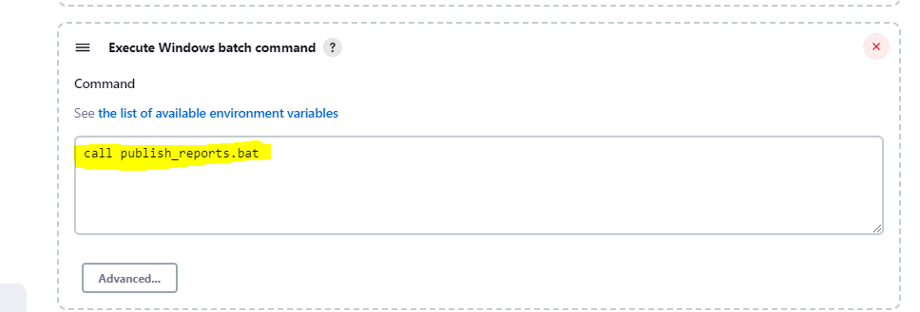

- Add POST BUILD step to publish HTML reports:
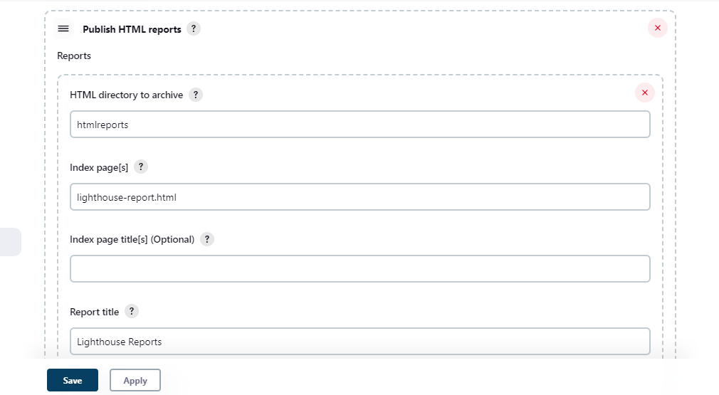
NOTE: These names should match with the ones given in the publish_report.bat file
Save and APPLY;

- Now do a Build again to include all the Build steps and to Publish Report:

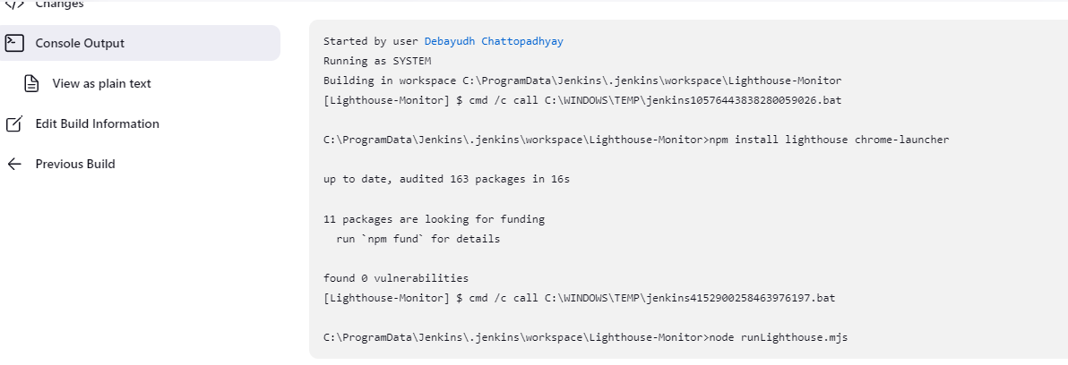
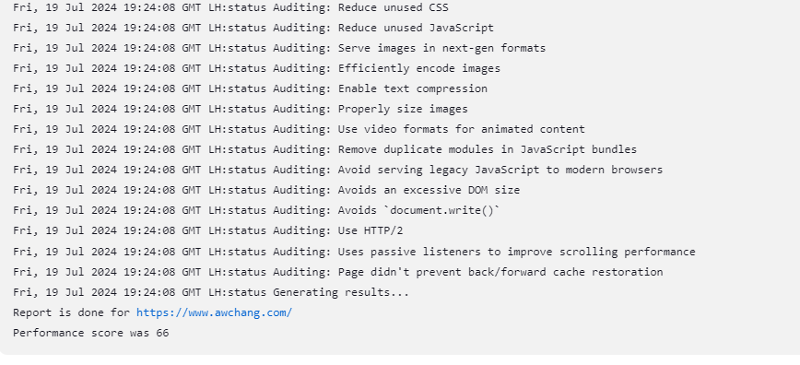
Wait for the build to get over and is a success:
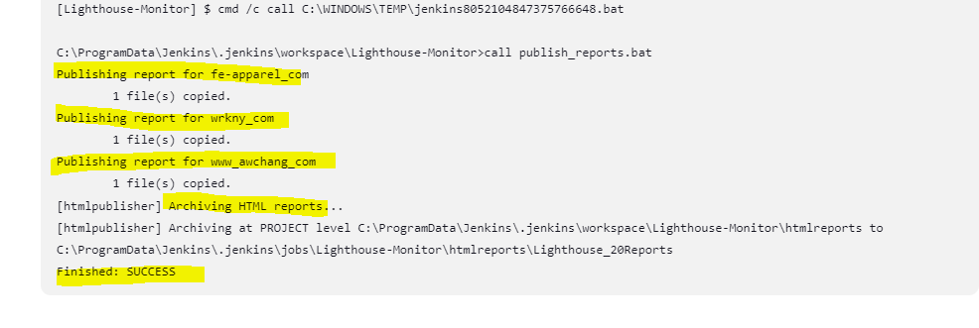

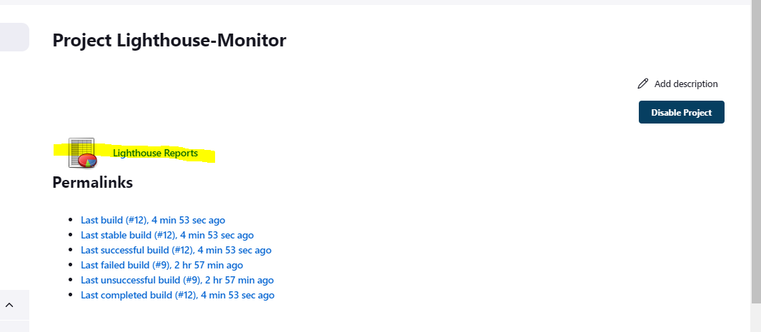
The Lighthouse Reports should appear under the project.

Click on the Lighthouse Reports:
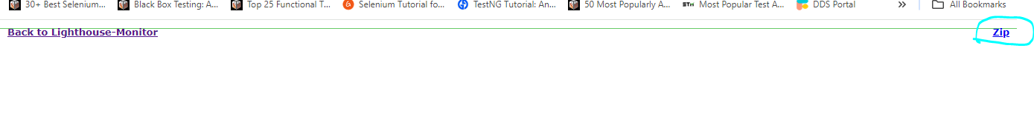

Download Zip (wait for the download to get over):
Get to your Download folder and check for the report zip:
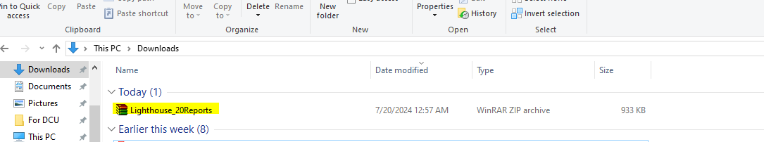

Open this:
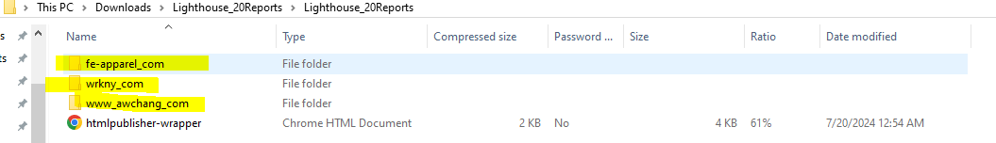

We will see a structure like this , a folder with the name of the website we tested for performance. Open each of these folders to get the Lighthouse report for that website:
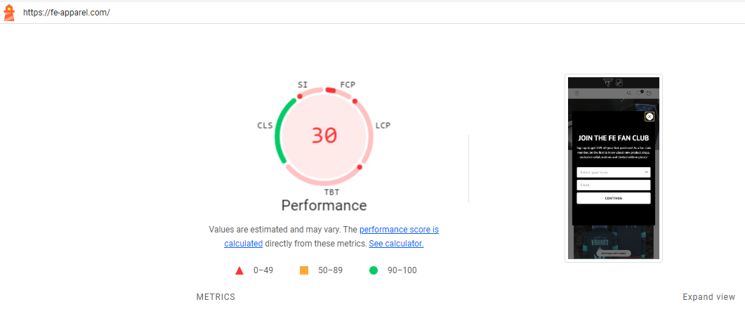

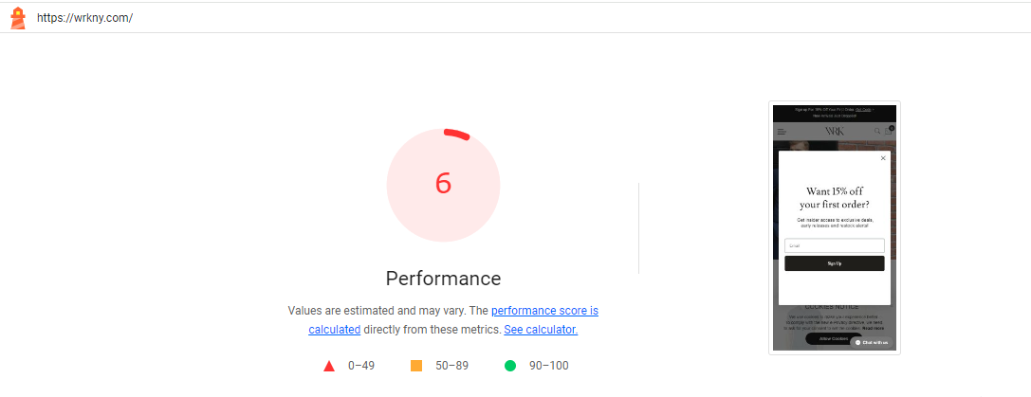

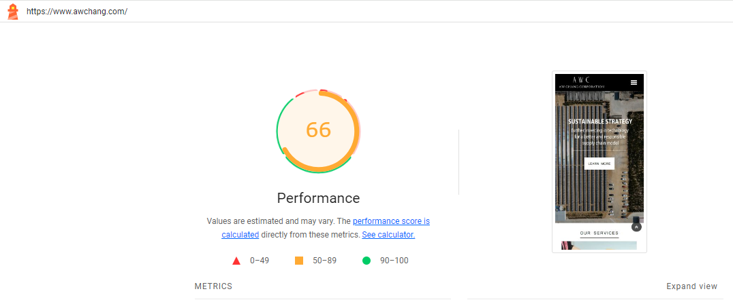

We can see the same reports from the workspace project folder:
